SQL DEVELOPER INTERSHIP
Task-1
1.Domain : Library
2. Library entities and relationship:
Library Management System:
- Library — owns — Book
- Type: One-to-Many (1:N)
- Explanation: One library can own many books, but each book record belongs to one specific library.

Book — borrowed — Issue
- Type: One-to-Many (1:N)
- Explanation: A book can be issued multiple times (many issue records), but each issue record refers to a single book

Issue — published by — Member
- Type: Many-to-One (N:1)
- Explanation: Each issue is associated with one member who borrowed the book. A member can have multiple issues.

Staff — handles — Member
- Type: One-to-Many (1:N)
- Explanation: One staff member can handle or assist many members, but each member is usually assisted by one staff at a time (during issuing or returning).

published by — Publisher
- Type: Many-to-One (N:1)
- Explanation: Many books can be from one publisher. Each book is linked to a single publisher.

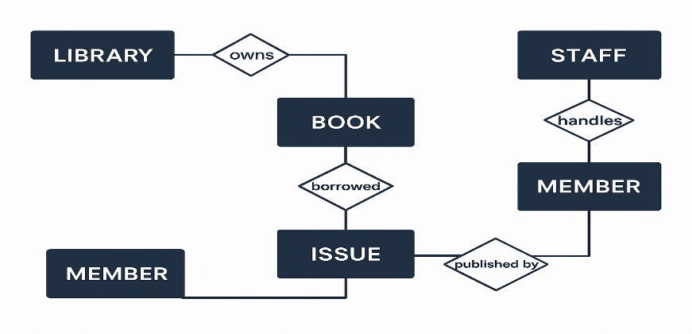
3. CREATE TABLE:
i. Library Table
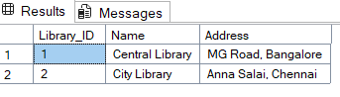
CREATE TABLE Library (
Library_ID INT PRIMARY KEY,
Name VARCHAR(100),
Address VARCHAR(200)
);

ii. Publisher Table
CREATE TABLE Publisher (
Publisher_ID INT PRIMARY KEY,
Name VARCHAR(100),
Address VARCHAR(200),
Contact VARCHAR(20)
);
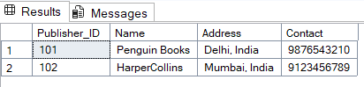
iii. CREATE TABLE Book (
Book_ID INT PRIMARY KEY,
Title VARCHAR(100),
Author VARCHAR(100),
Genre VARCHAR(50),
ISBN VARCHAR(20),
No_of_Copies INT,
Library_ID INT,
Publisher_ID INT,
FOREIGN KEY (Library_ID) REFERENCES Library(Library_ID),
FOREIGN KEY (Publisher_ID) REFERENCES Publisher(Publisher_ID)
);
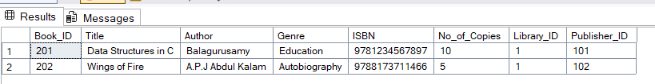
iv. Member Table
CREATE TABLE Member (
Member_ID INT PRIMARY KEY,
Name VARCHAR(100),
Phone VARCHAR(15),
Email VARCHAR(100),
Address VARCHAR(200),
Membership_Date DATE
);
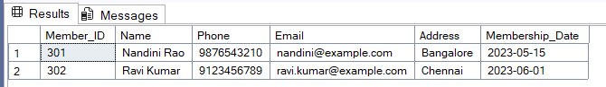
4. Define Primary Keys And Foreign Key?
- A Primary Key is a unique identifier for each record in a table.It must be unique and cannot be NULL.Each table can have only one primary key.
- A Foreign Key is a field in one table that refers to the Primary Key in another table.It creates a relationship between two tables.It ensures referential integrity (you can’t assign a non-existent value).
Example: Library_ID INT,
FOREIGN KEY (Library_ID) REFERENCES Library(Library_ID)

